38.56: a) See Problem 38.4: 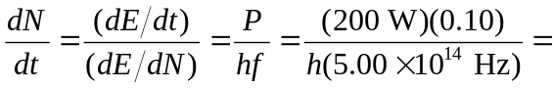
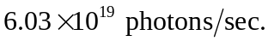
b) Demand 